**Car Sales V3 Testing Screenshots**

**Screenshot 1 -** Display All Customers**:**

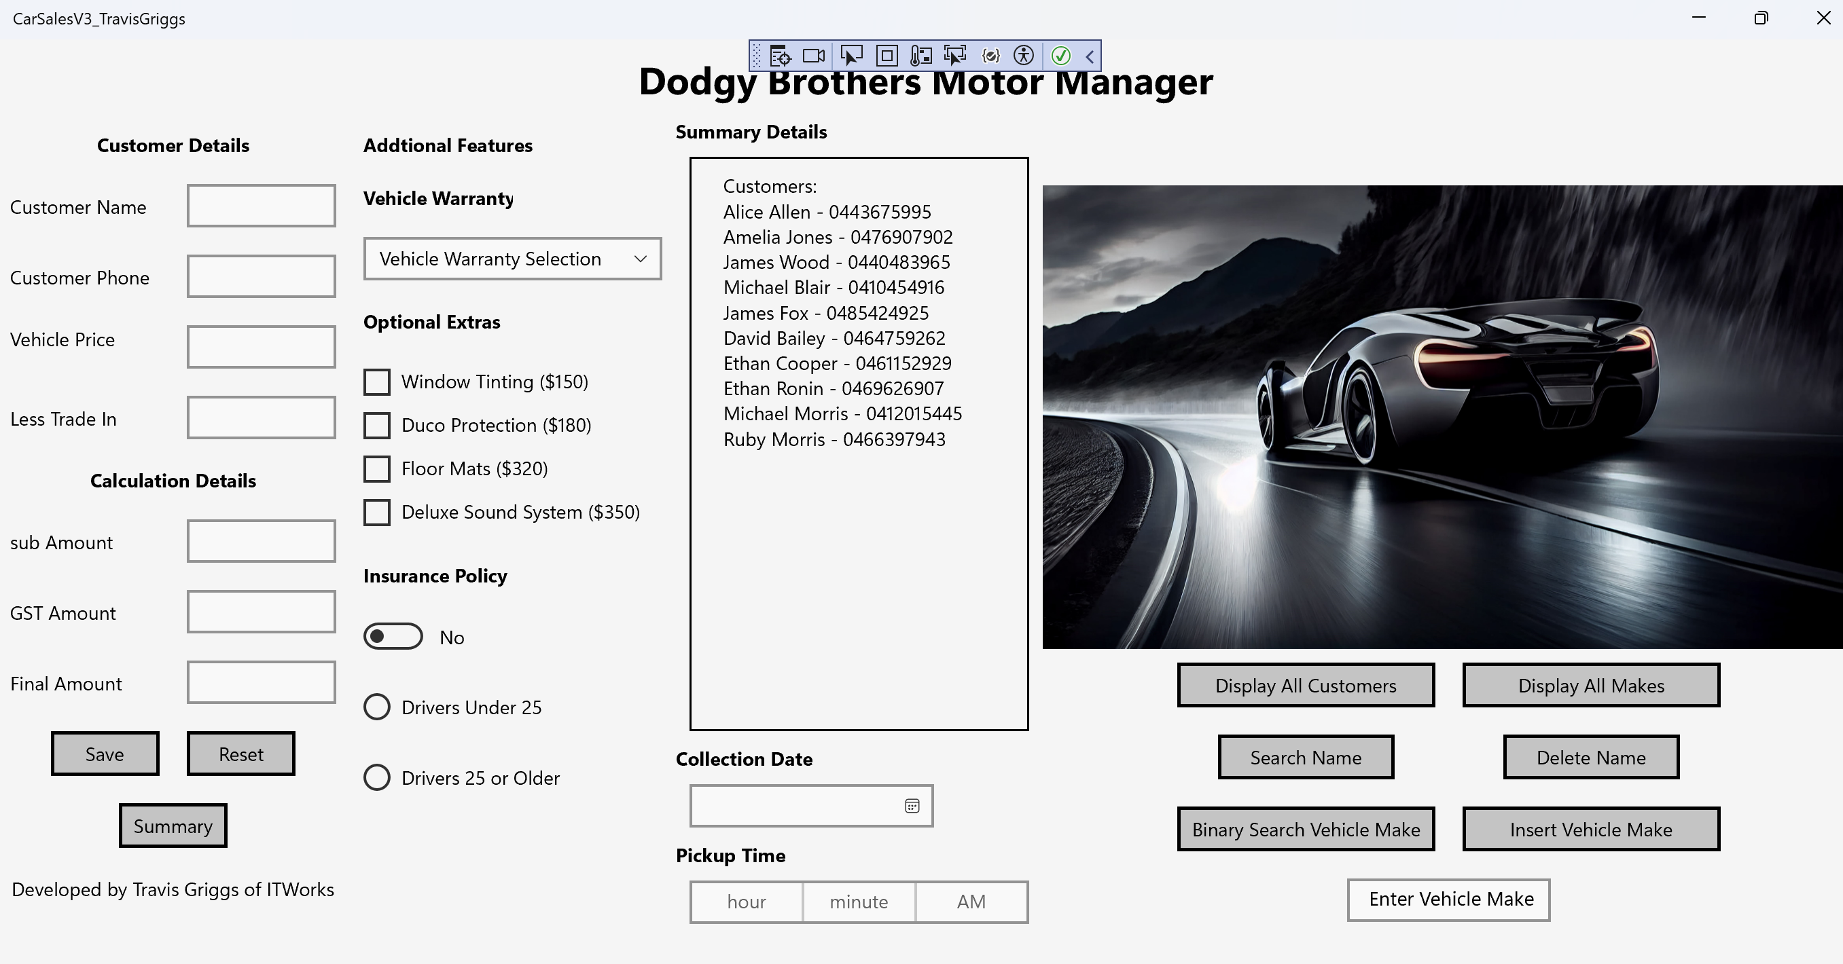

**Screenshot 2 -** Search Name Found**:**

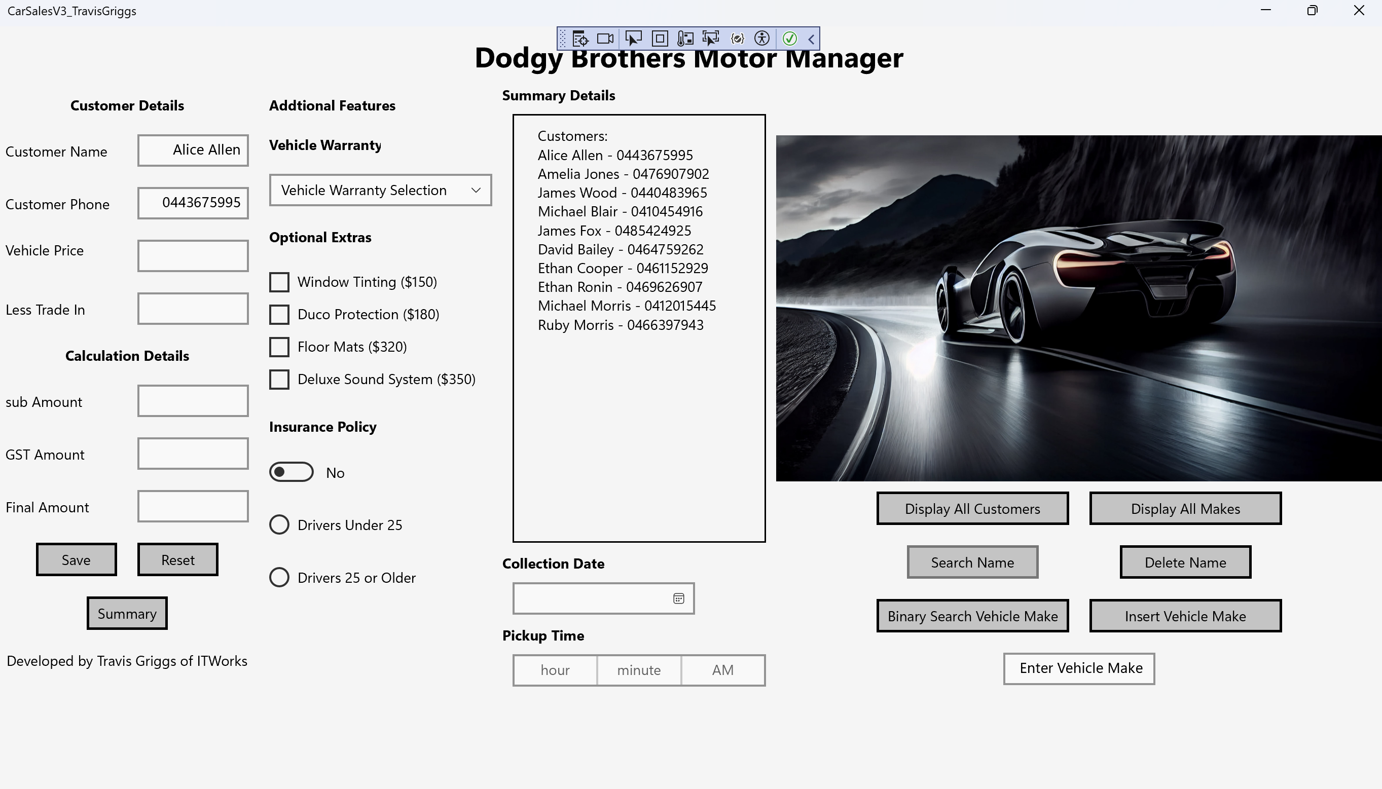

**Screenshot 3 -** Search Name Not Found**:**

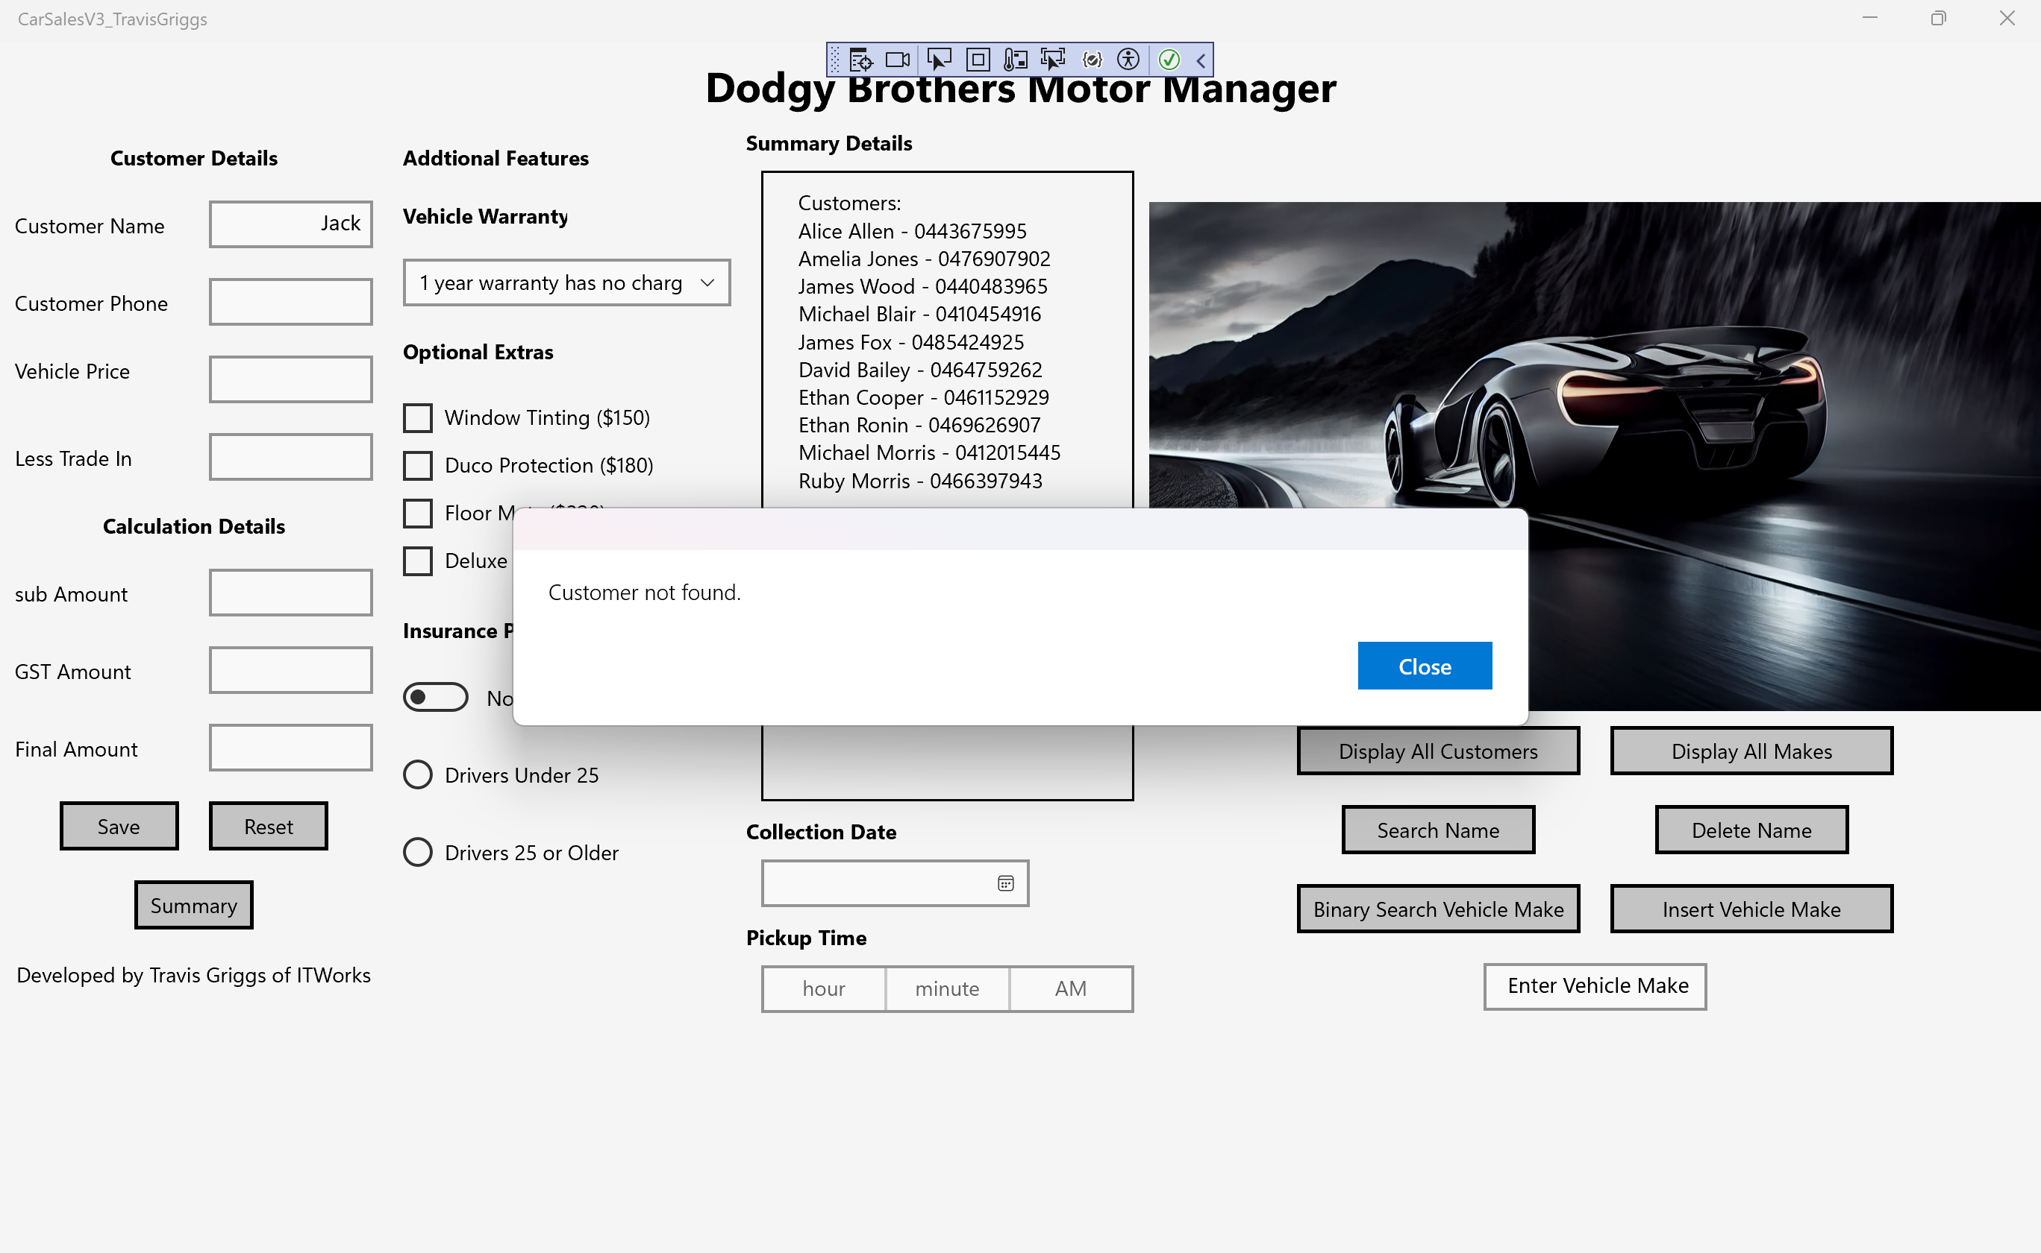

**Screenshot 4 -** Delete Name Found**:**

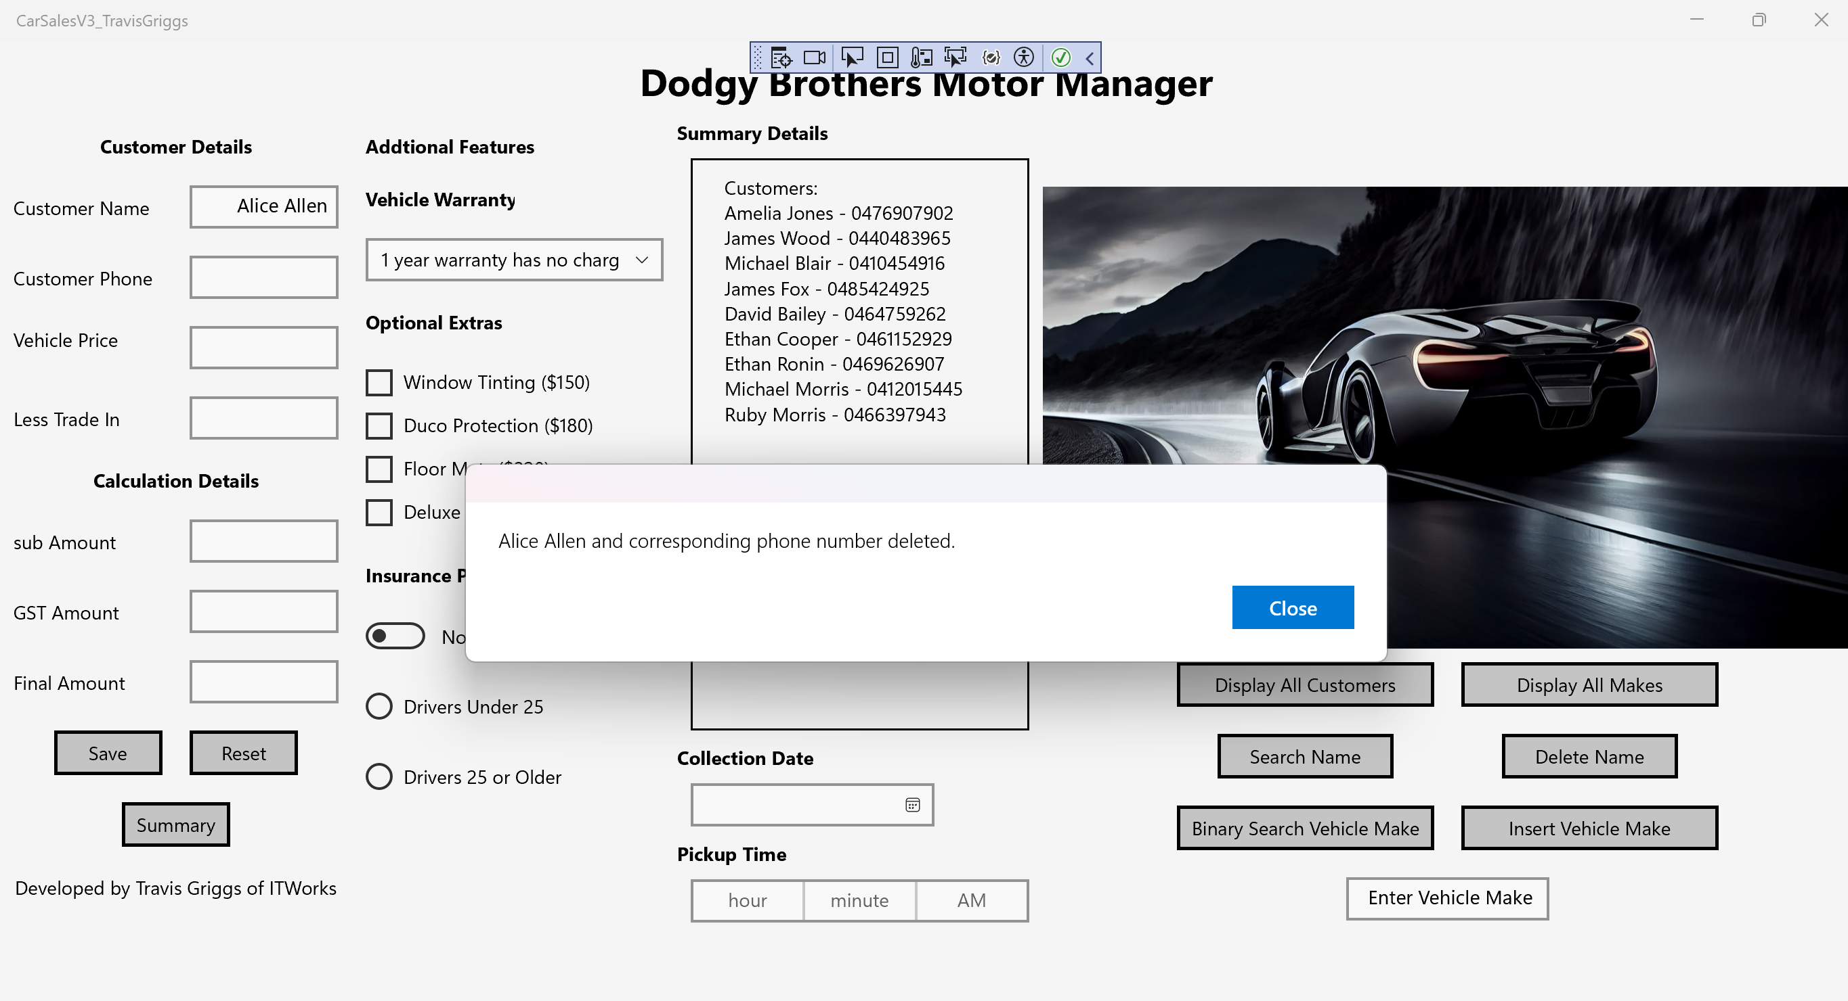

**Screenshot 5 -** Delete Name Not Found**:**

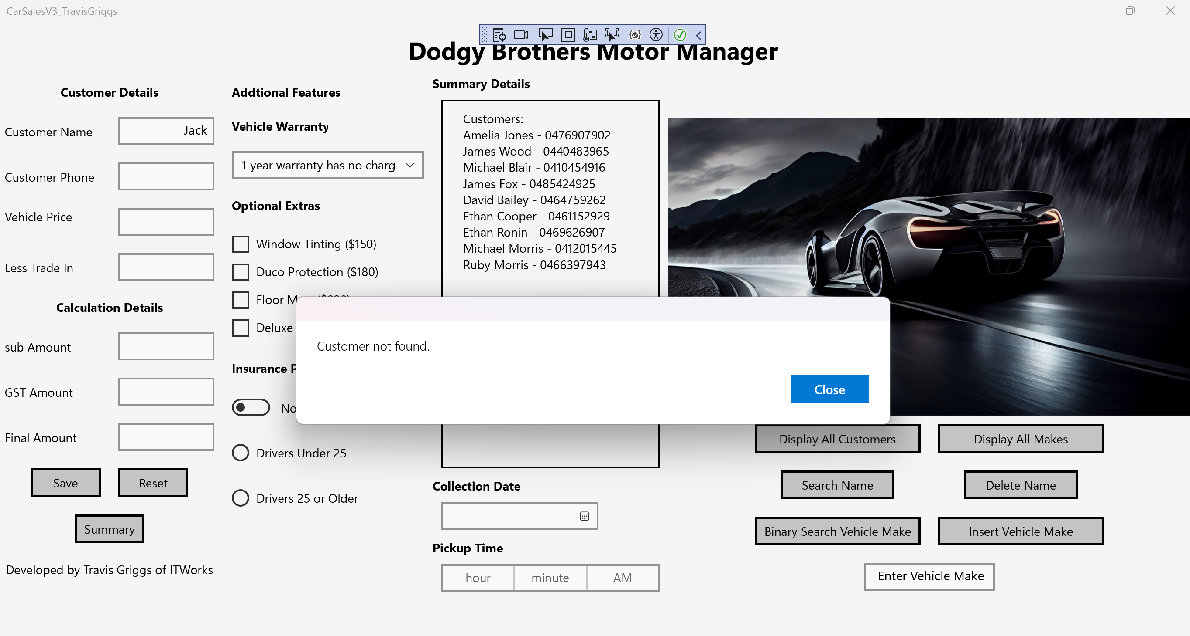

**Screenshot 6 -** Display All Makes**:**

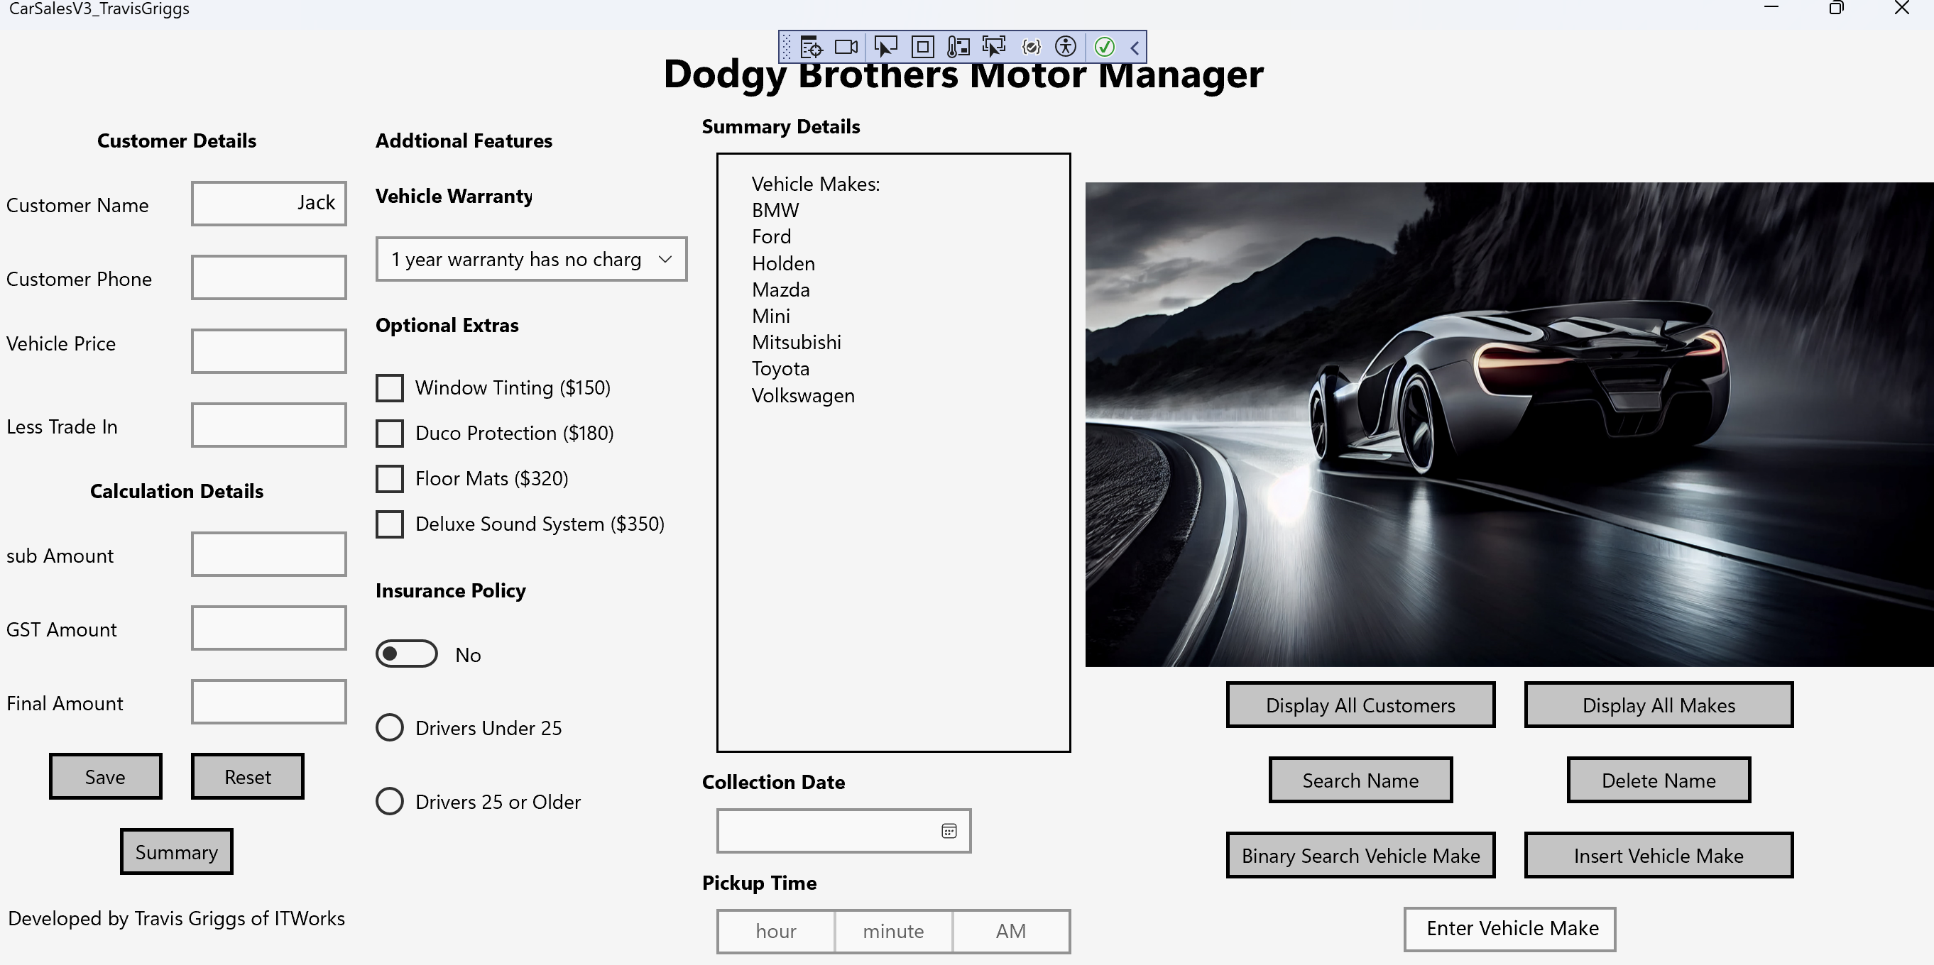

**Screenshot 7 -** Binary Search Make Found**:**

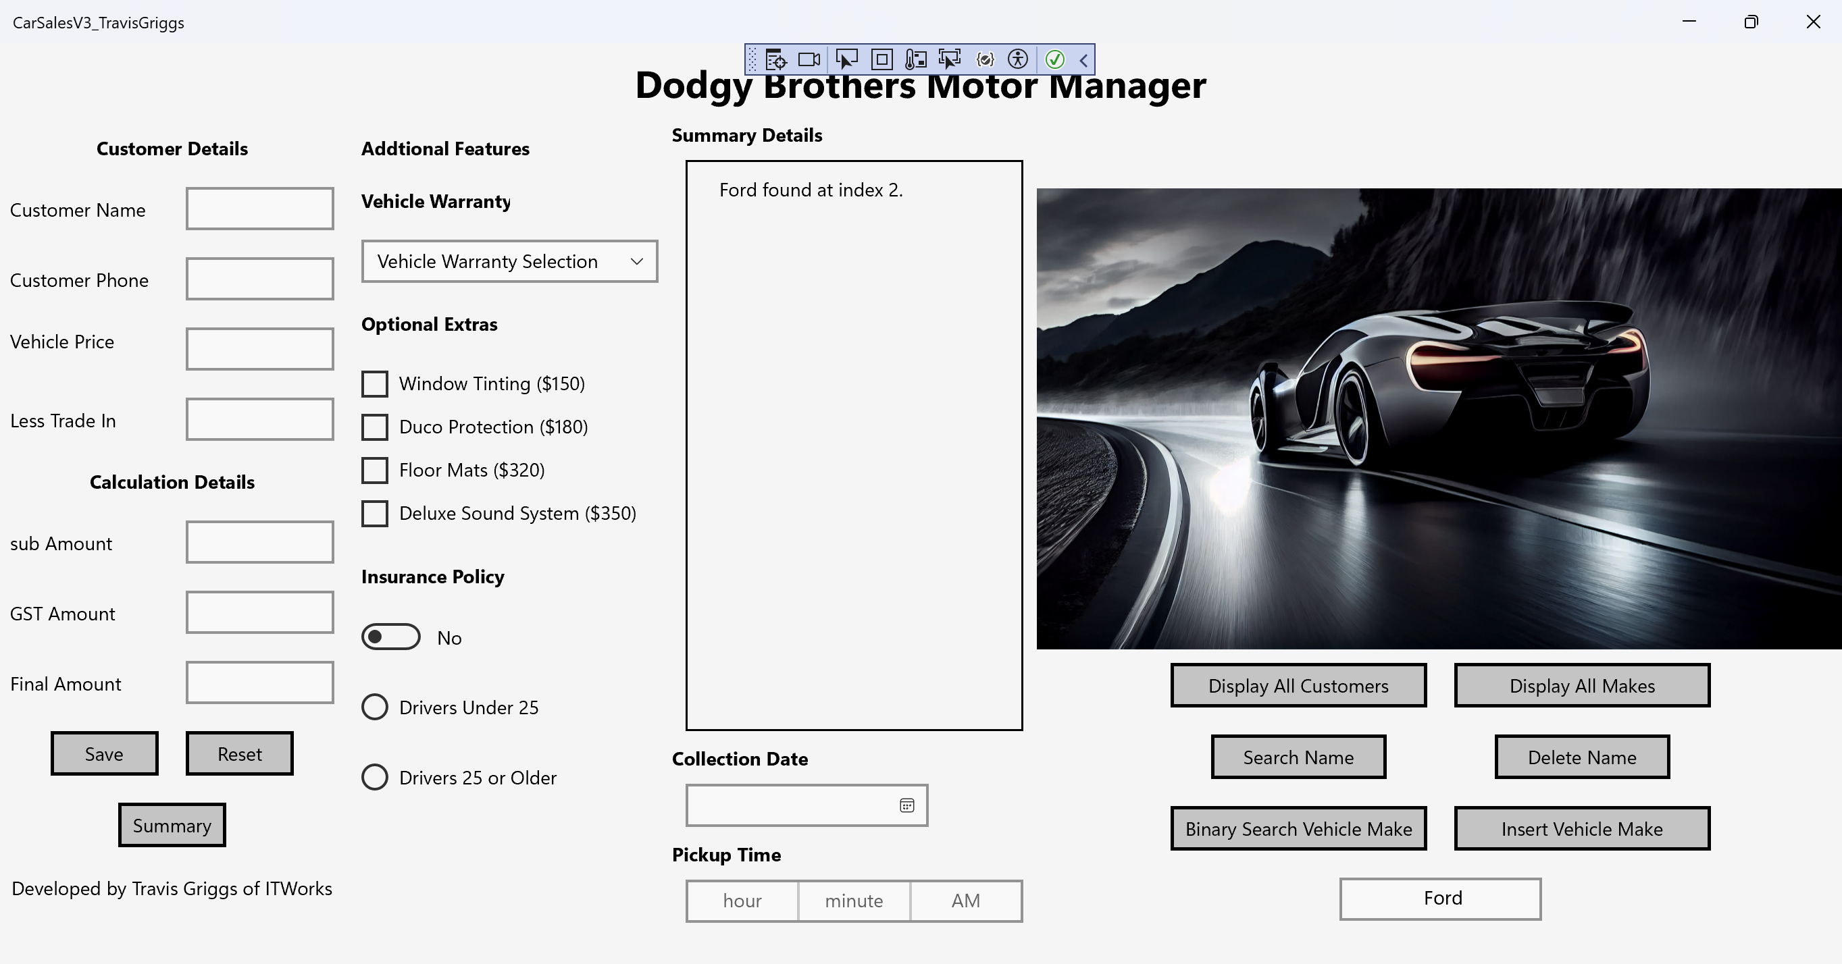

**Screenshot 8 -** Binary Search Make Not Found**:**

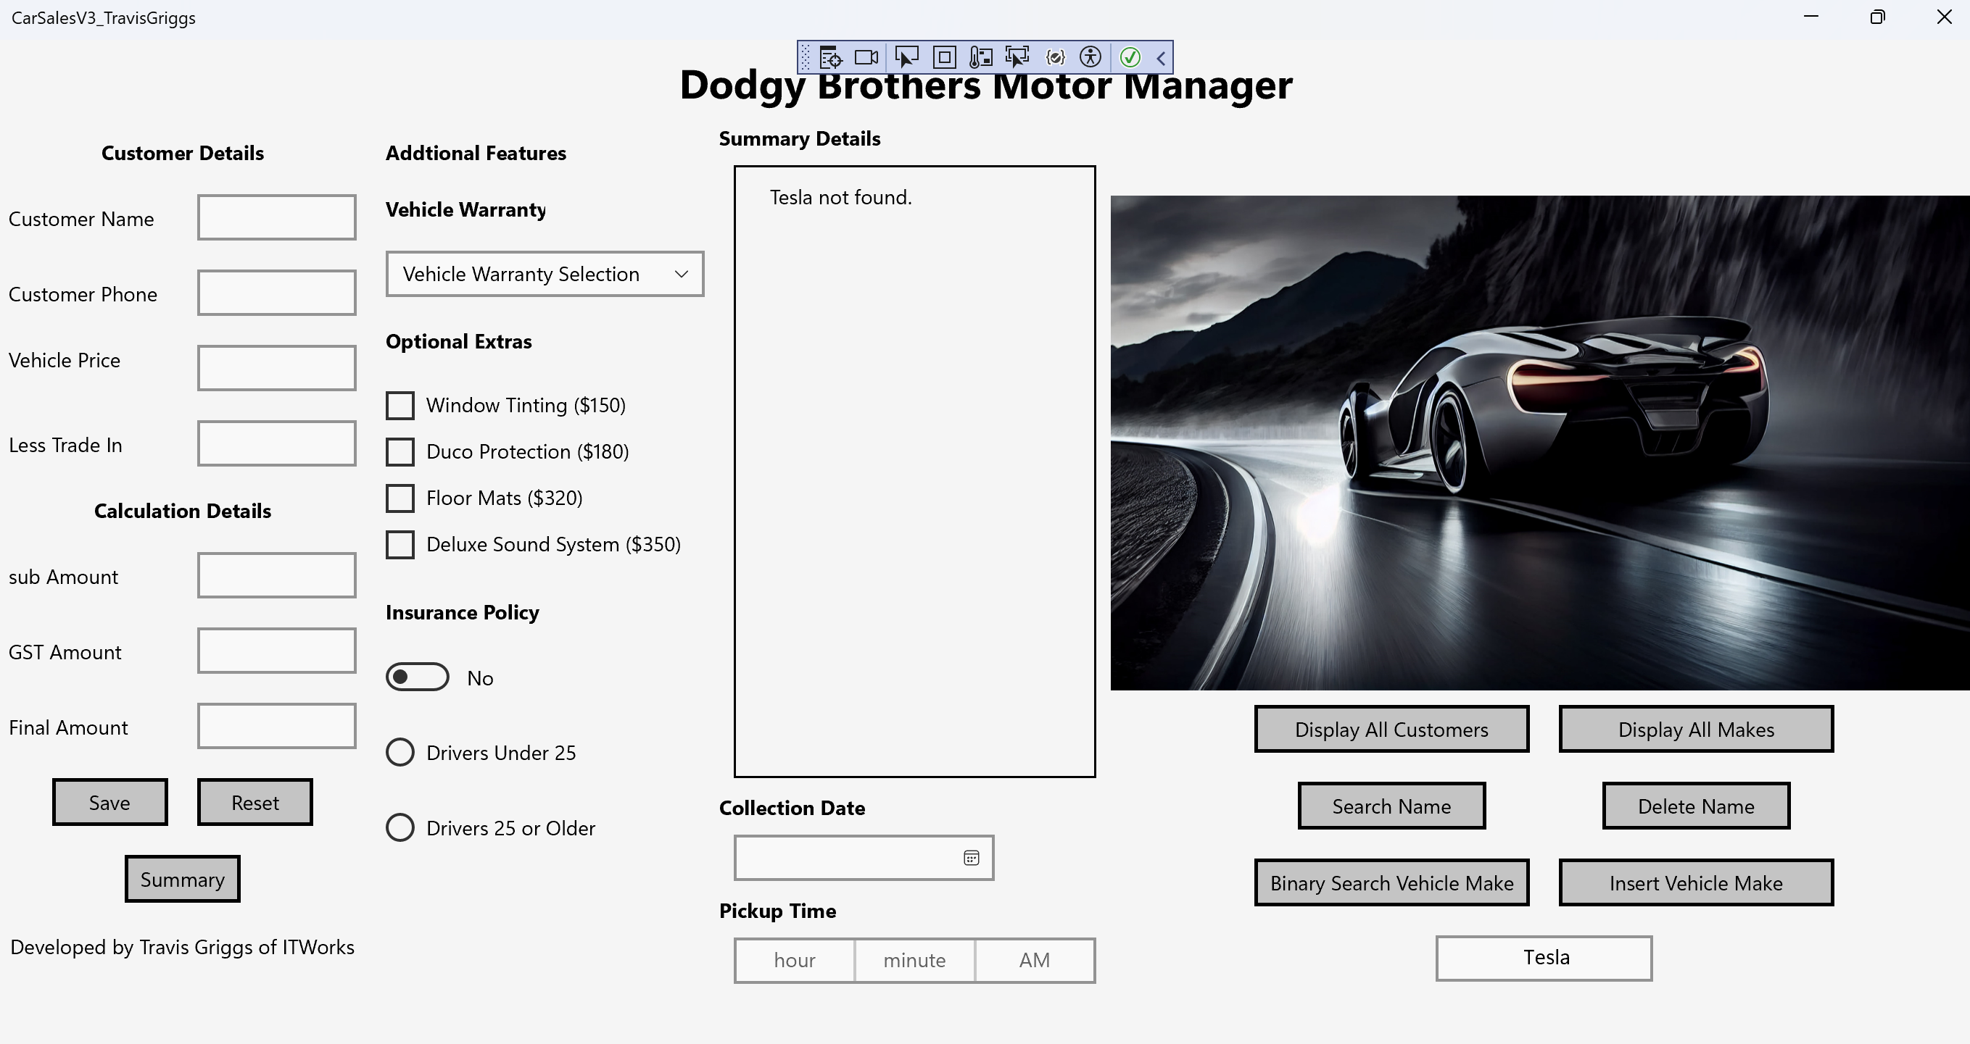

**Screenshot 9 -** Insert Make Found**:**

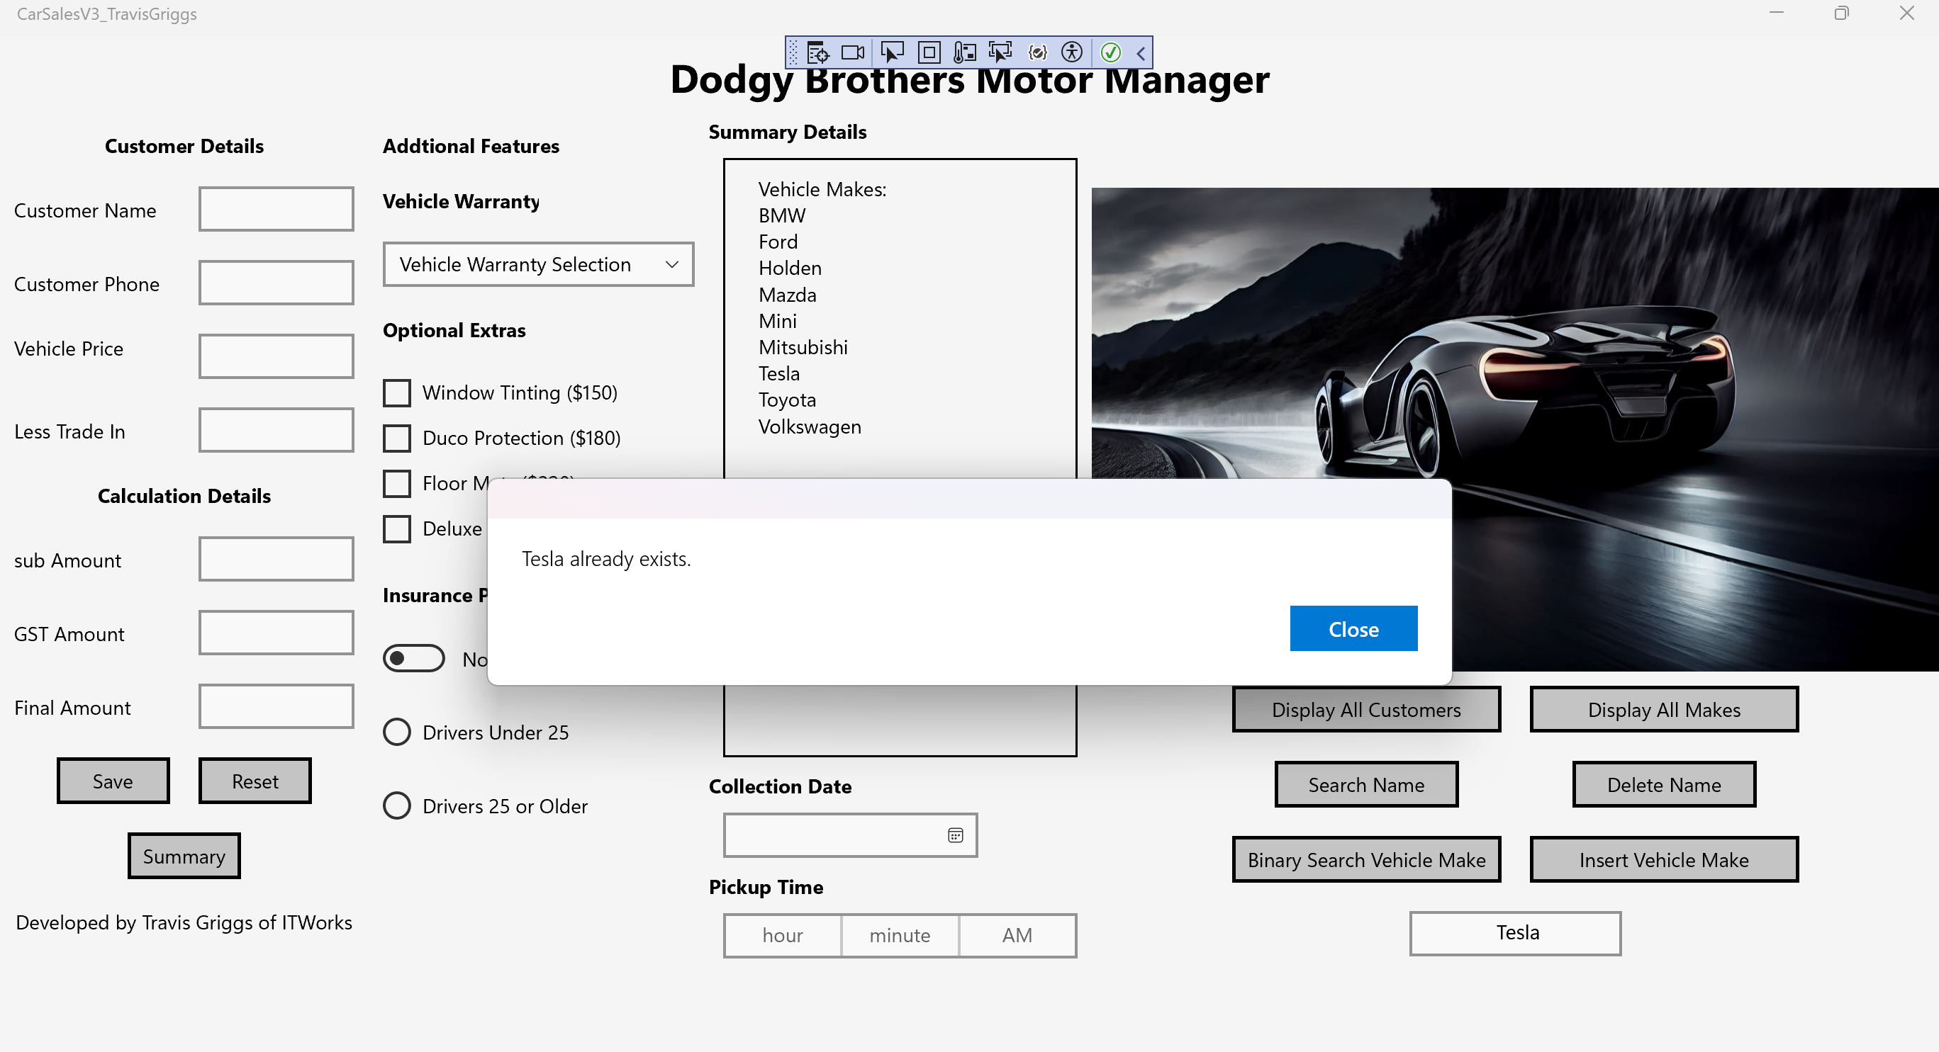

**Screenshot 10 -** Insert Make Not Found**:**

